18. How to check for Agency Compliance

When agency staff log into Nourish, they should always make sure they have recorded their name in the Daily Note of every interaction they complete.

To check this, you can run a ‘Timeline’ report to check by following the steps below.

- Click on the Administration ‘cog’ in the vertical menu on the left-hand side.

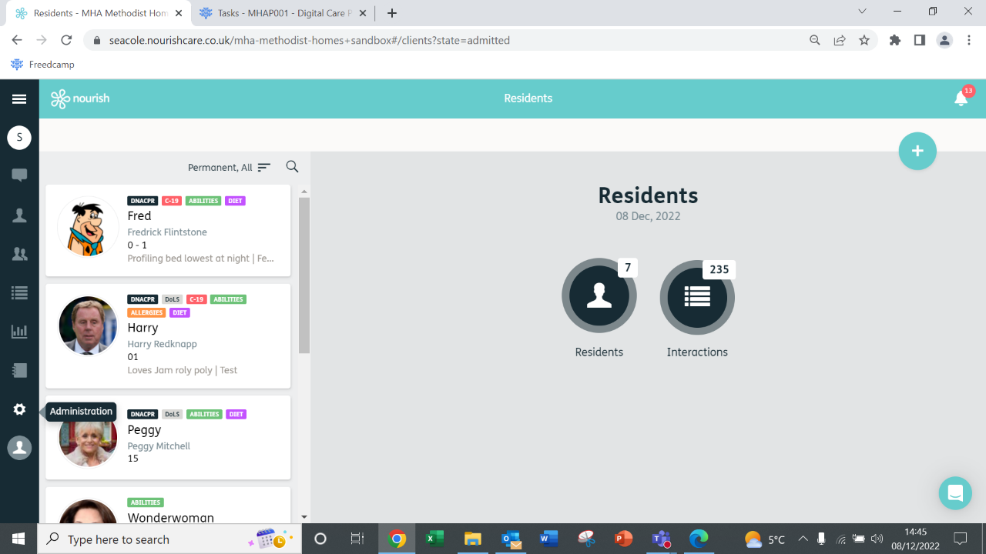
1.

- This will open the Administration Menu, click on ‘Reports’.

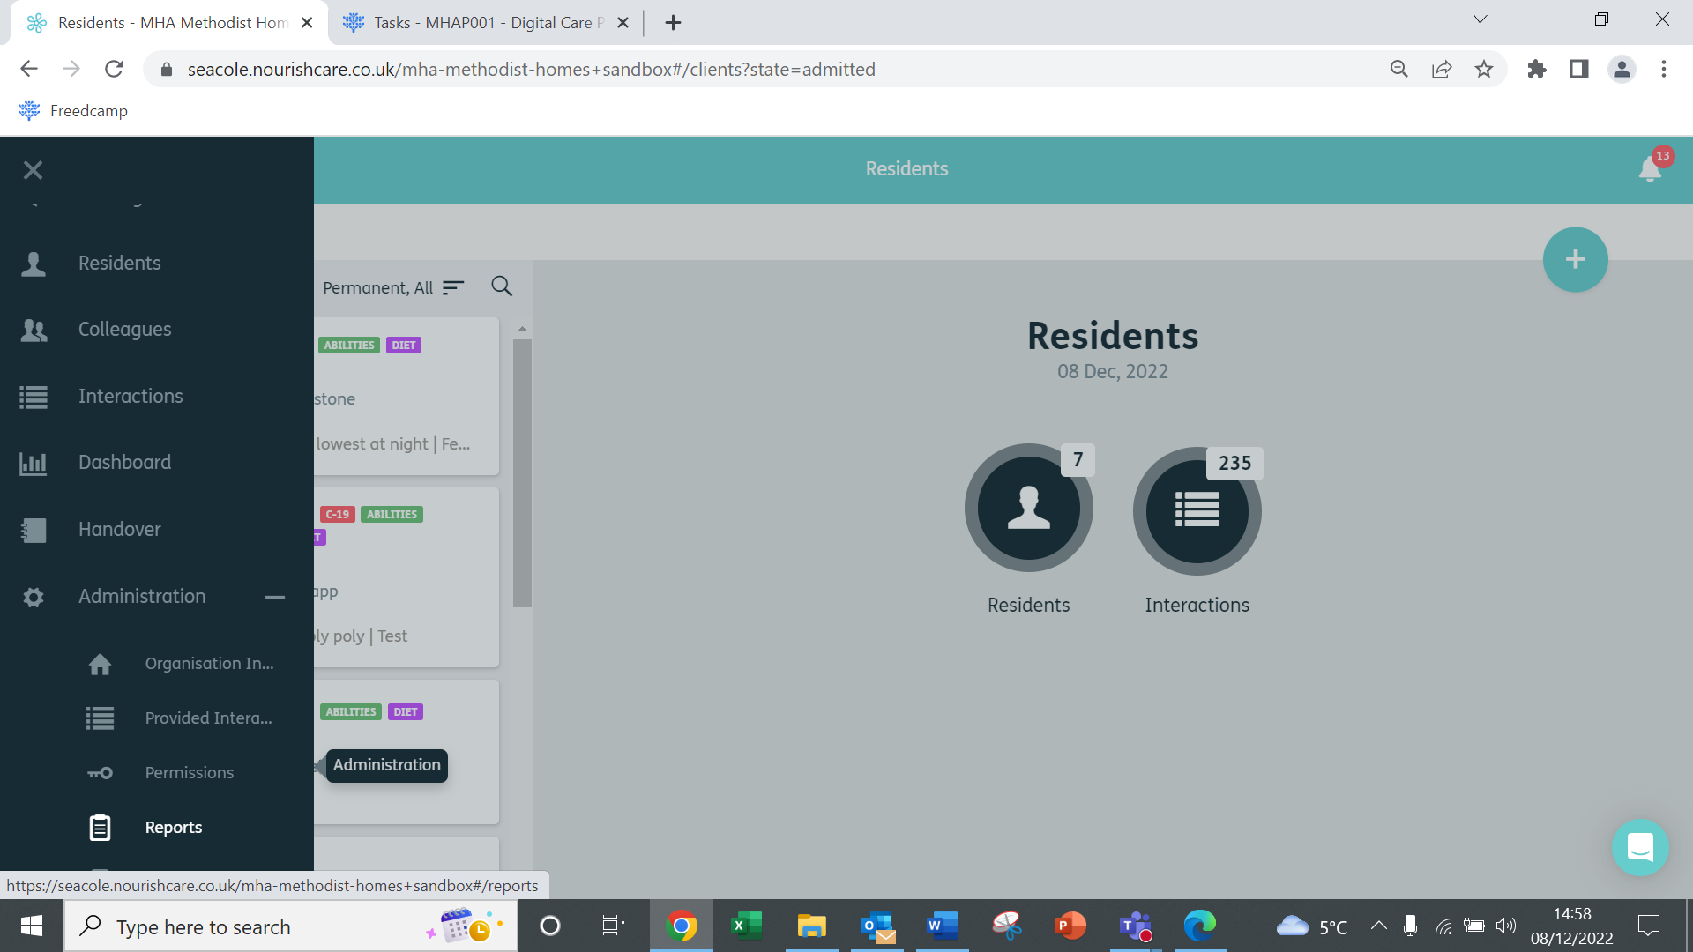
2.

- This will open the reports menu. To create a new report, click on the ‘Blue Plus’ in the top right corner.

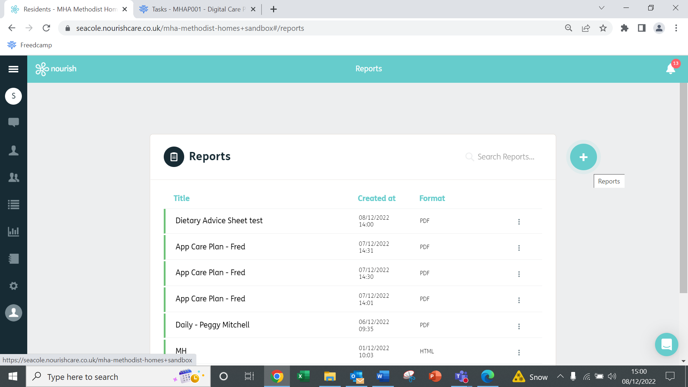
3.

- You can now create a new report, choose ‘Timeline’ from the drop-down box.

- Give your report a title (remember reports stay in the report list)

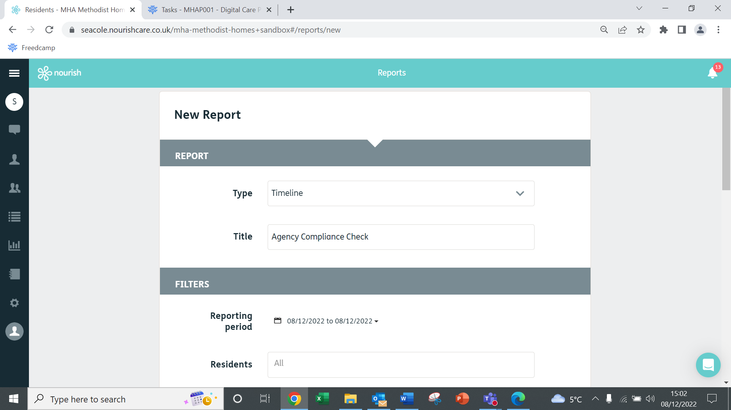
5.
4.

- Scroll down to the ‘Filters’ section and choose your date range by clicking on the dates.

- You can also choose which residents, for the purposes of this report to check Agency Compliance, leave ‘Residents’ and ‘Interactions’ at ‘All’.

- Leave Record and Status settings as they are.

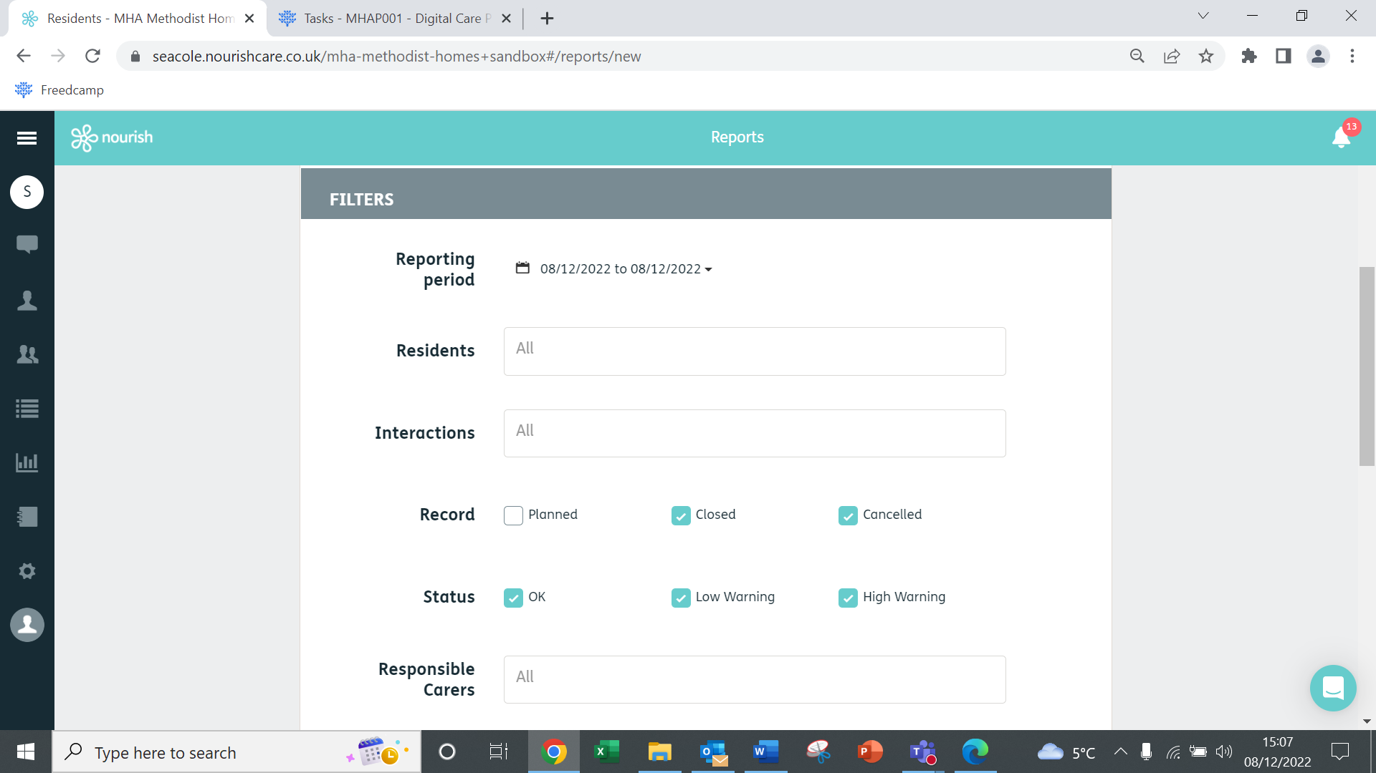
8.
7.
6.

- Select your home’s agency log in ‘Responsible Carers’ if you start typing this will auto-populate.

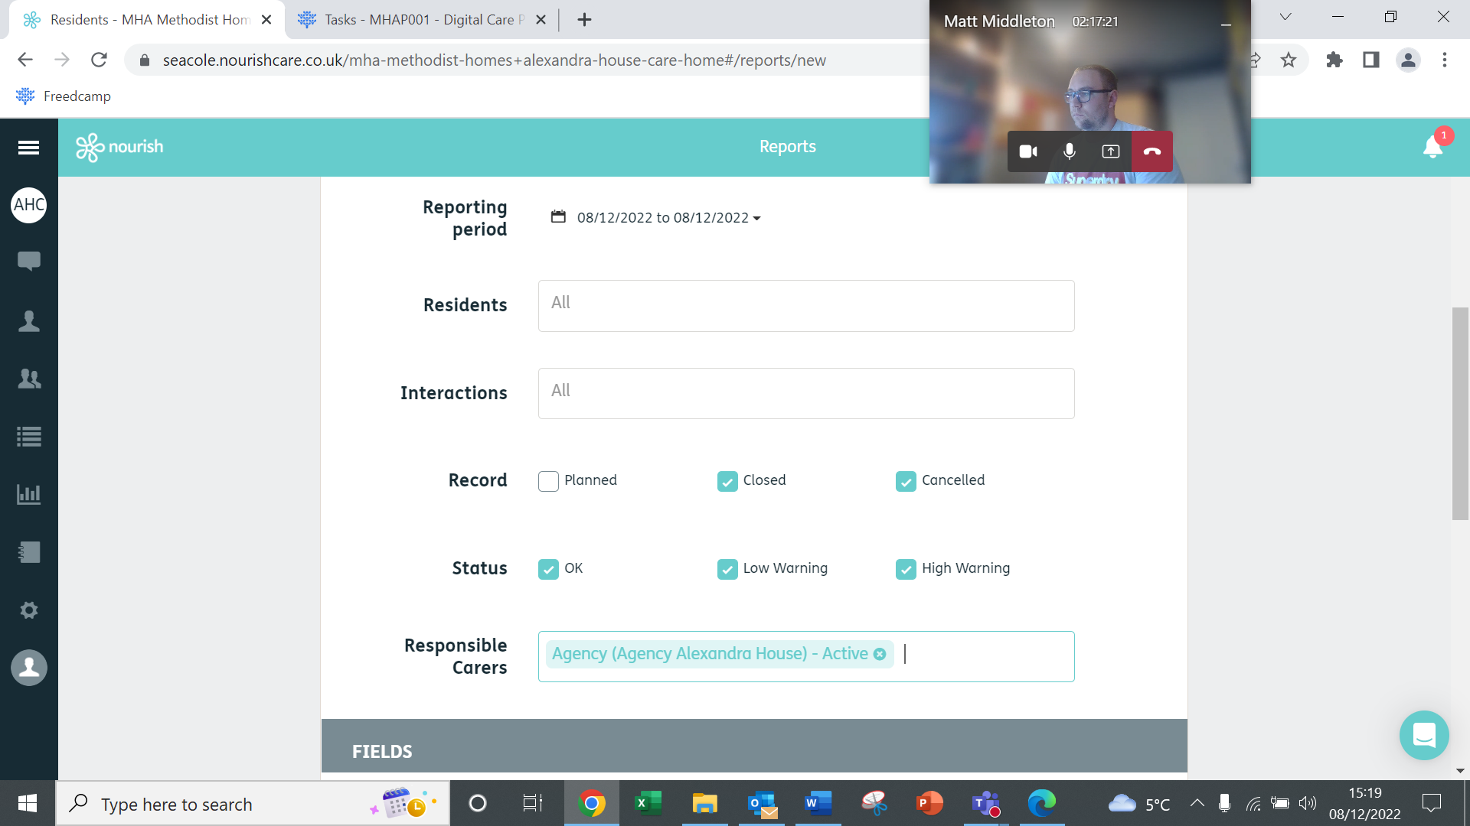
9.

- Scroll down and untick ‘Parameters’ as we are only looking to see if there is the agency carer’s name in the Daily Note and do not need to see all the parameters of the interaction.

- Tick PDF (or another format if you prefer).

- Untick New Page per Resident

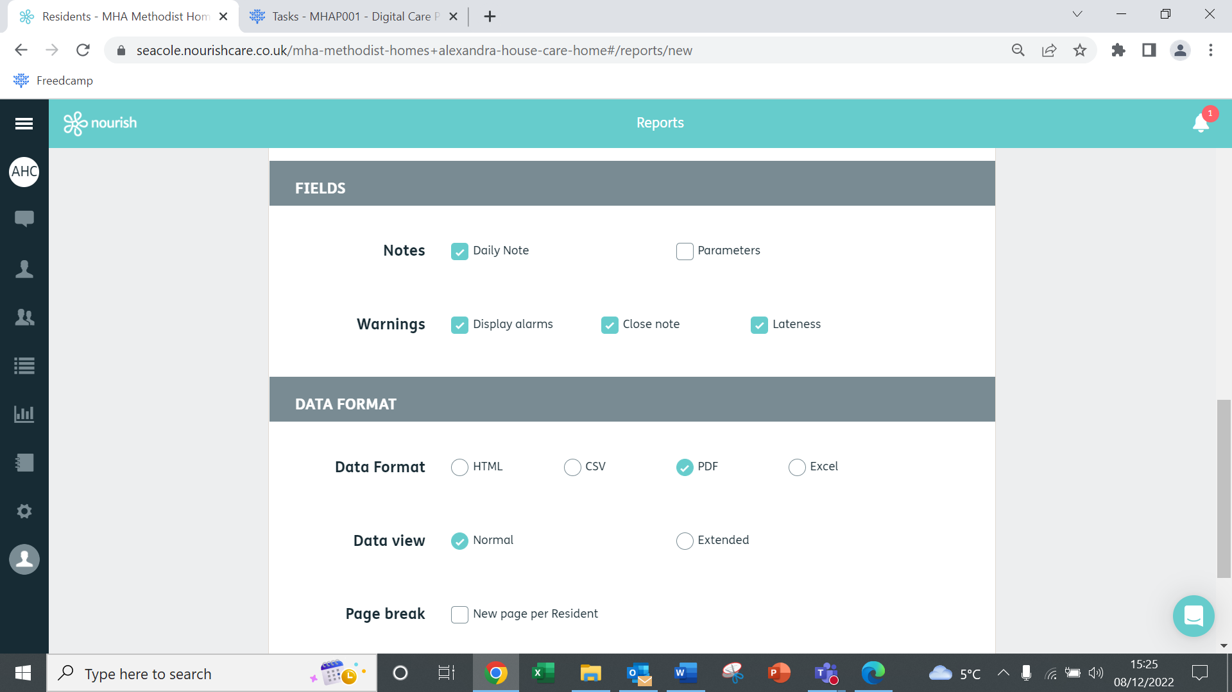
12.
11.
10.

- Click Save

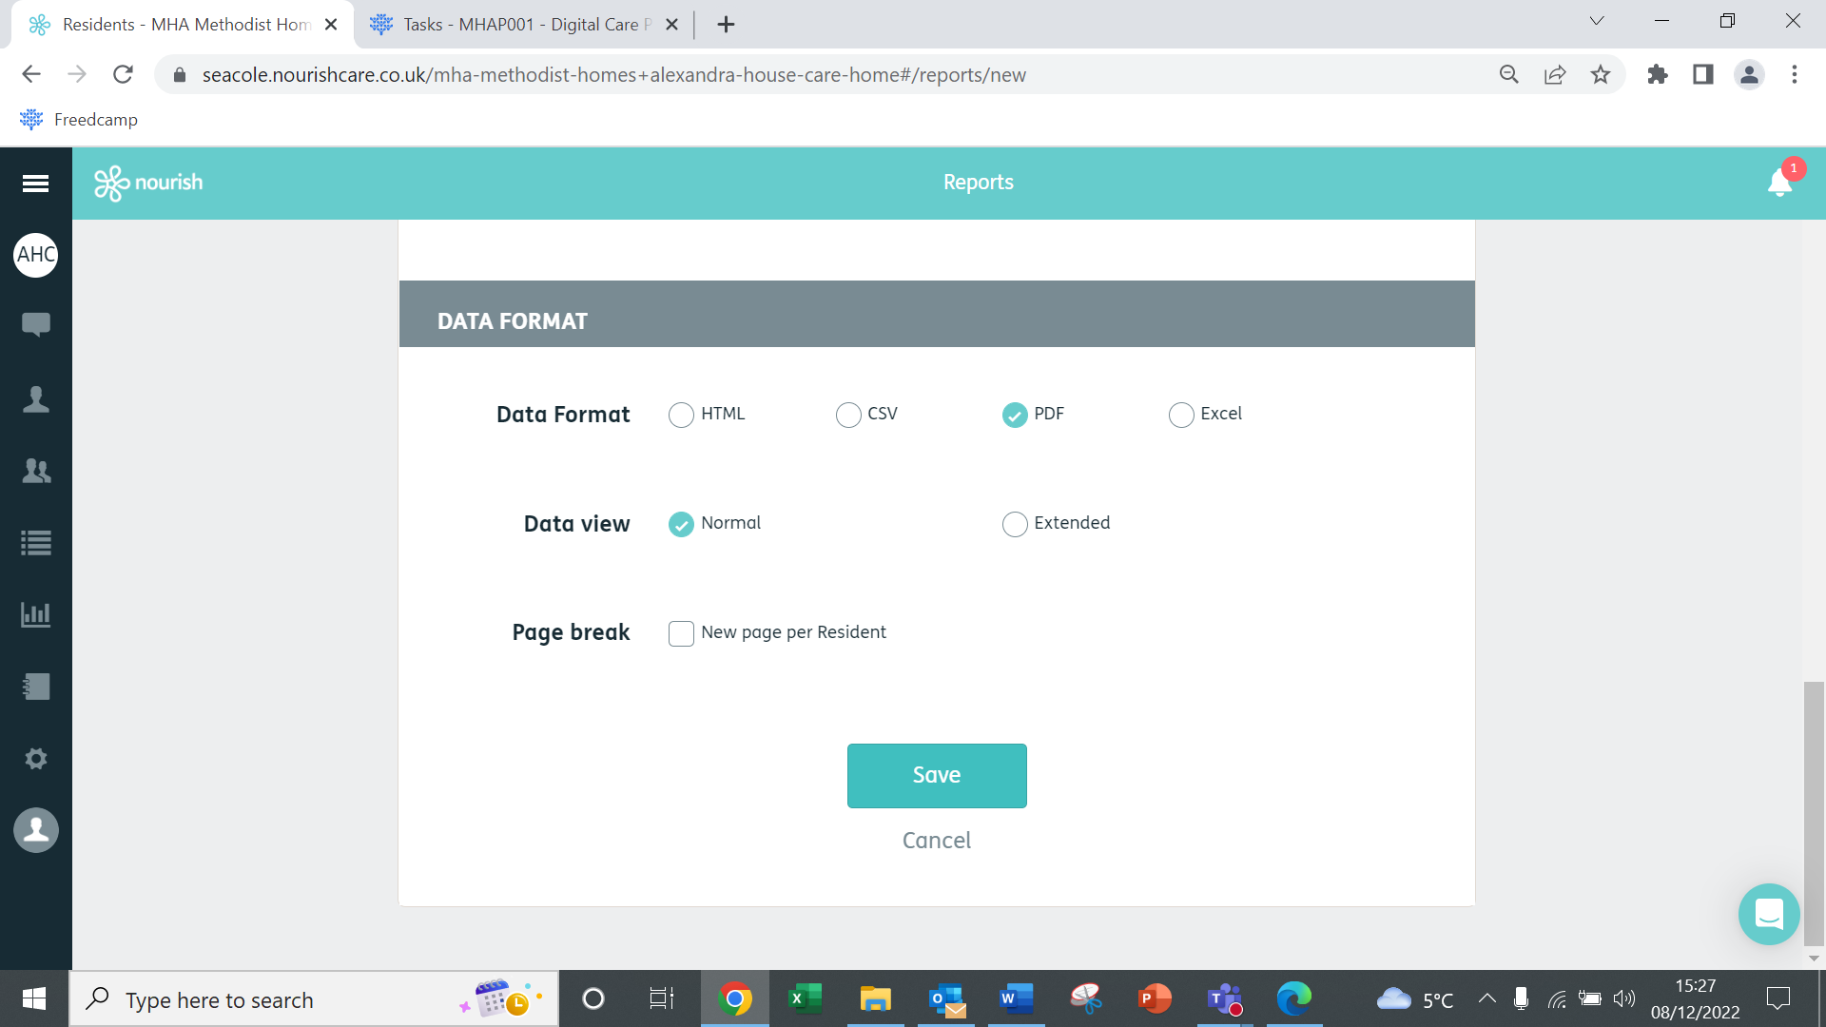
13.

- Wait for your report to load, when it has loaded the bar on the left will turn green. Click on the 3 dots to the right and click download if this is what you would like to do.

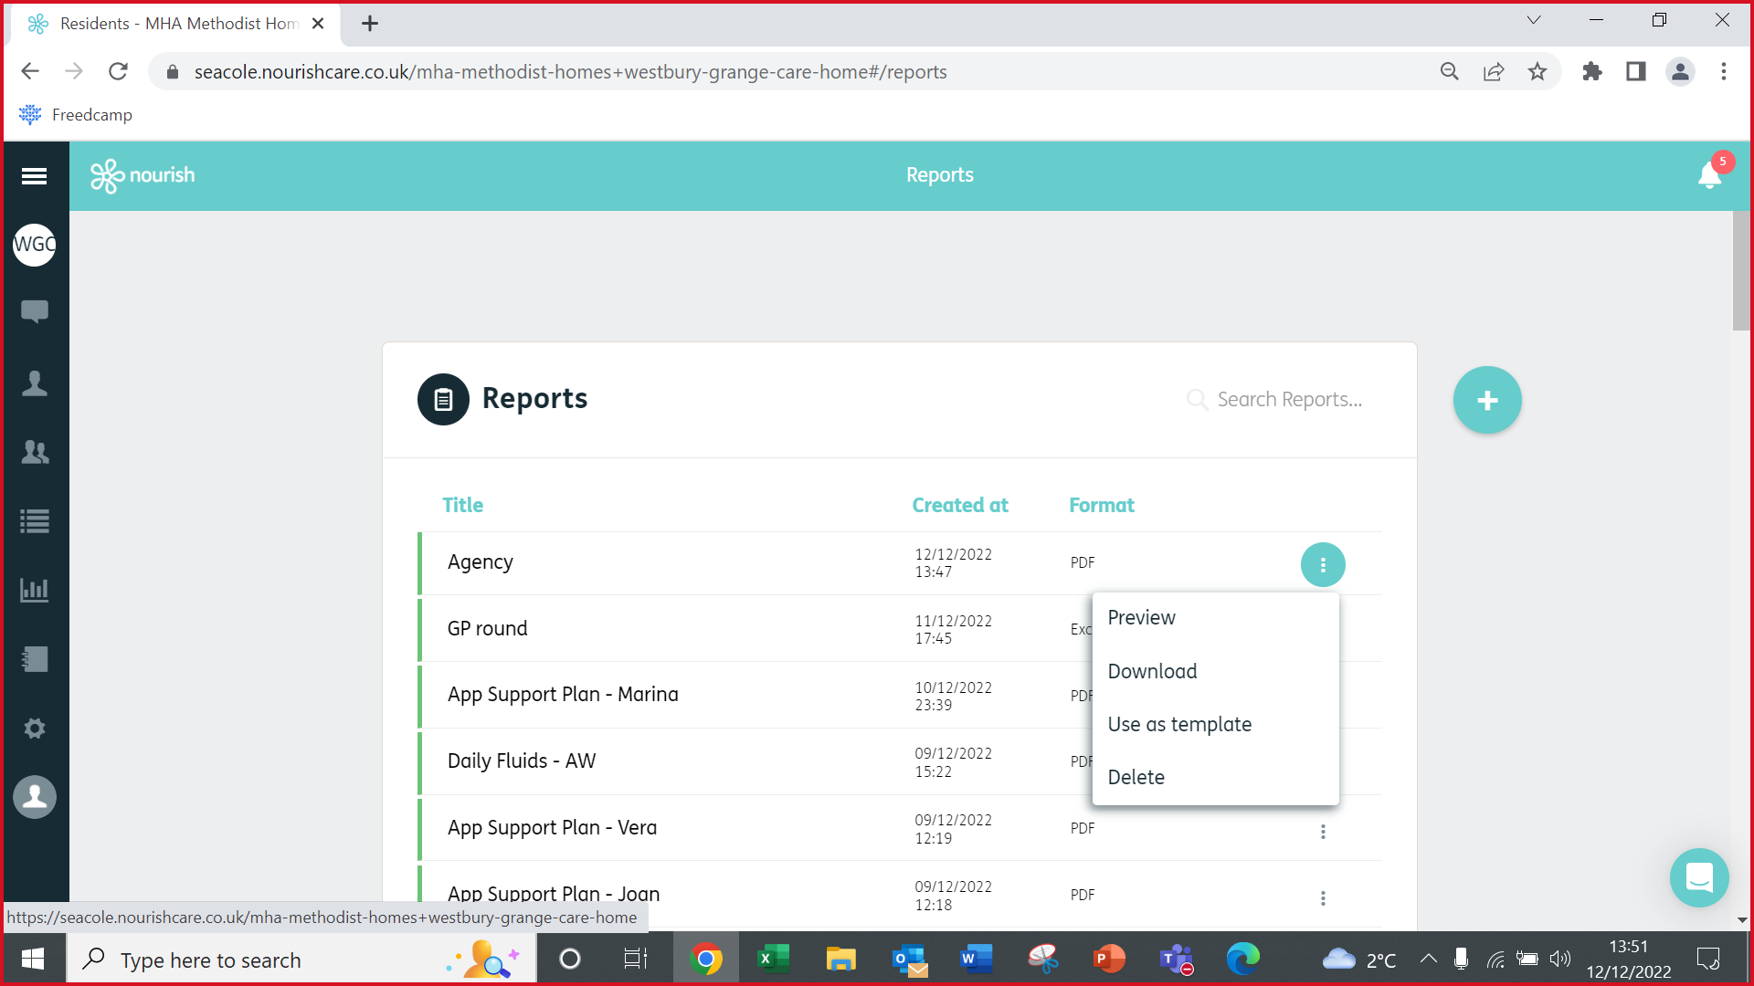
14.

- Open your report. Check through the interactions – these will be all the interactions which have been closed solely using the agency log in. You can review these to ensure the name of the Agency Carer has been entered into the Daily Note.
15.
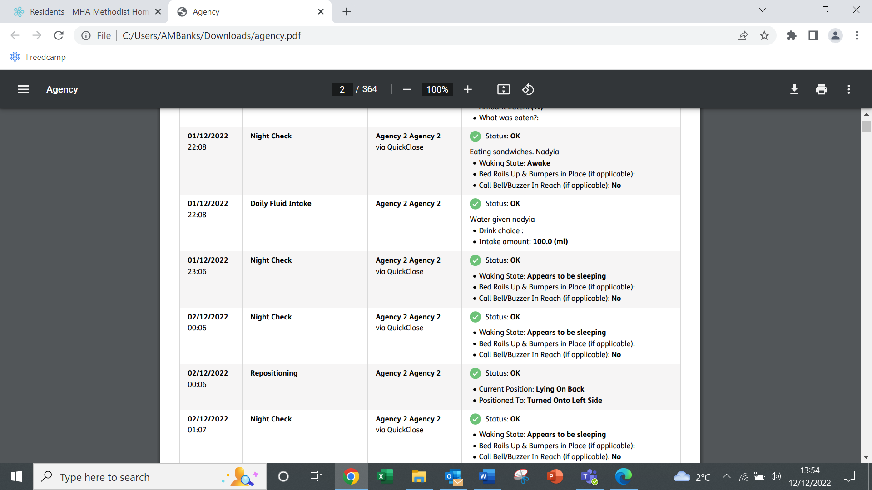
Agency Name should be shown here

Top Tip!

All agency carers should be recording their name in the daily note of the interactions they close. If there is no name here, this is because they have not written it.

